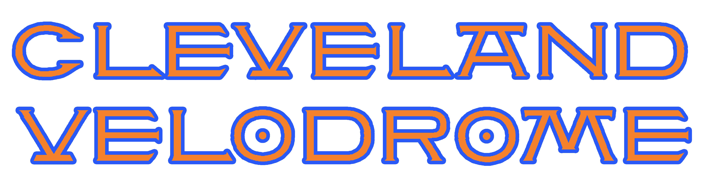

Cleveland-Detroit Challenge
Saturday September 22nd – 1:30pm to 3:30pm.

Here is a the program for the race event
1.) 50 Lap Roll-Up
2.) Flying Lap attempts
3.) "A" Riders 20 lap scratch race
4.) Junior Riders 10 lap scratch race
5.) "AA" Riders 20 lap scratch race
6.) "A" Miss&Out
7.) Junior Miss&Out
8.) "AA" Miss&Out
9.) "A"s Team Pursuit
10.) Junior Team Pursuit
11.) "AA" Team Pursuit
12.) "A/AA/Junior 50 lap Madison
13.) "A/AA" 100 lap Madison

After the roll up we will determine who are "A"s and "AA"s.

Track builder Dale Hughes will run the program and is bringing several riders from Detroit. ATRA release forms are required. Day of registration only. $20.00 entry fee. $300 minimum prize list.

Spectator viewing on our 100 foot long deck is free. There is a $5.00 spectator charge for entry into infield Hospitality Area.

There is a Track 101 session from 10:30 to noon. Track will be open to racers after the Track 101 session.

